  - DANIEL MARTINEZ JR
YOUTH/ASSOCIATE PASTOR
dmartinez@fcclynden.org | 360.223.0206

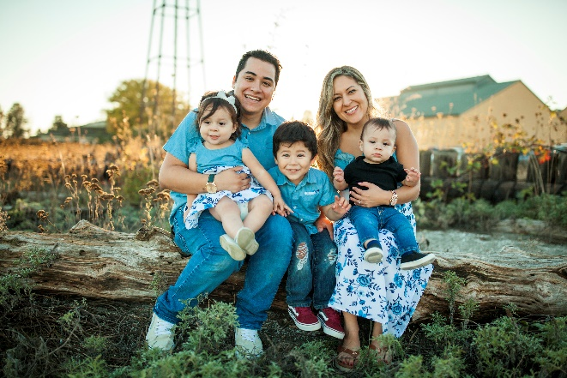
Professional Summary:
Seasoned youth pastor offering 6 years of experience in pastoral care and spiritual leadership to students grades 6-12 and post-high. Committed to making disciples and guiding individuals transformed by gospel. Background in organizational leadership, ministry program development, psychology, music, and youth ministry. Experience includes building volunteer teams to support church music and youth activities. Skilled leader, organizer, and problem-solver; also, in selecting topics, preaching through scripture, and leading music.
Accomplishments:
- Planned and led 4 mission trips to Mexico, Guatemala, and California
- Collaborated with team of 40 in the development of worship ministry
- Discipled and mentored over 150 students over the last 6 years in youth ministry
- Served in a congregation of 350+ in a worship, youth, and associate capacity
- Philosophy discipline award Whatcom Community College 2018
- Certificate in Human Services

Skills:

- MS Office
- Project organization
- Team manager
- Youth Ministry
- Shepherding
- Preaching
- Event coordinator
- Musical Worship Leader
- Fluent in Spanish
- Leadership Development
- Pastoral Counseling
- Staff Management
- Budgeting
- Teaching
- Social Media Expertise
- Public Speaking
- Fundraising
- A/V, Sound, and Tech

Work History:
Youth/Associate Pastor / Faith Community Church – Lynden, WA / Aug.2015-Current

Bilingual Customer Support / Faithlife Corporation – Bellingham, WA / Sep.2013-July.2015

Retail and Sales / American Eagle, 1 Bellis Fair Parkway – Bellingham, WA / May.2012-Aug.2013

Education:

Trinity Western University
Expected in 2021
Bachelor of Psychology
Whatcom Community College Graduated 2019
Associates in Arts and Science

Lynden High School
Graduated 2014
High School Diploma

