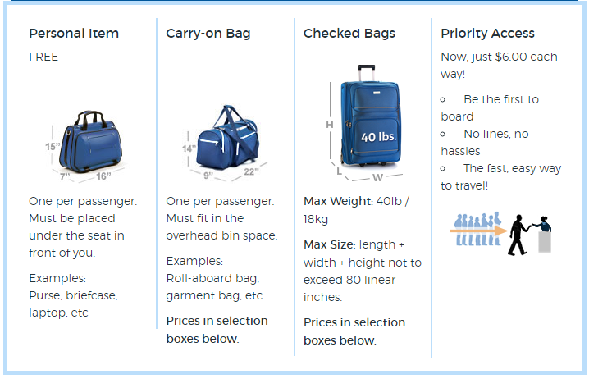
Size for Bags:
Prices:
Personal Item: Free
Carry-on Bag: $90
Checked Bag: $90
- These prices are for both ways

Right now you have 1 checked back included in your price for the trip as well as a personal item.

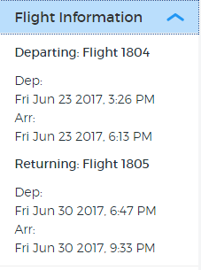

There is only 1 flights that allegiant has from Bellingham to San Diego. We will be leaving Friday June 23 and returning Friday June 30.

The day of departure, we’ll meet at Bellingham Airport at 1:00 PM

When we return, you can expect us to be back at FCC no later than 11:00 PM

