When: August 3-10, 2017
Where: El Zorrillo, México
Who: Middle and High School Students
Cost: $450, this includes air fare, food, and transportation.
What: We’ll be taking 7 days away from our day to day lives to pour ourselves into the children, adults, and all those who live in the community by showing God’s love through service. This mission trip is for those who have a desire to serve others, to travel and visit a new culture, to make new friends, to grow closer to those at youth group, to see what poverty is in person not just pictures, and most importantly it’s for those who have a desire to grow closer to God and know Him better.

What will we be doing?
We are going to be helping a local Pastor, Mario, lay the foundation for a church in Ensenada this year! There will be a team that goes before us and starts laying down blocks, and we’ll come in and finish up with that as well as start laying concrete for the foundation. This isn’t a project we will finish, but we’re going to play a small part in constructing this building. We will be going through a study I’ll prepare together, as well as have youth lead devotionals both morning and evenings. You don’t need to have any building/working experience to come. There will be plenty of guidance and help for all of us (myself included) who have no building experience.

Tentative Schedule:

Friday: Leave FCC at 4:00 AM. Drive to Seattle airport for flight leaving at 8:30 AM. We’ll arrive in San Diego at 11:00 AM. Get our two 15 passenger vans and drive Maneadero, Baja California where we’ll be staying at Las Tres Palmas. Once we arrive around 3:00 PM, I’ll introduce you to the director of the ministry ground, Dennis Hollenbeck. We’ll unpack, eat dinner, play some group games and have student lead evening devotion followed by lights out.

Saturday: Leave early to head to the work site 20 min away, begin working on the site. After, we’ll head in the vans and head back to the ministry ground and wash up. After we’ll head to El Ranchito to have dinner, small group time, and devotions then head back to the ministry ground.

Sunday: Wake up early and head to Church, get some lunch and go continue to work on the project. Come back for dinner, small groups, devotions, lights out.

Monday-Wednesday: These days will look similar to the ones above, only we’ll incorporate a VBS for kids, some food distribution, as well as evangelizing into our days. Our number one goal is to show God’s love through our actions to the adults, teens, and children in this colony.

Thursday: We’ll head to Las Canadas from 8:00 AM-5:00 PM. After come back and pack up to head out the next day.

Friday: Leave Las Tres Palmas at 12:00 PM and head to do touristy purchases. Cross the border and get ready for the flight leaving at 9:00 PM. Arrive in Seattle at 11:30 PM. Arrive back at FCC at 2:00 AM.

What’s our Goal? Our goal is not to build church, or bring items that they “need”, but to bring faith, hope, and love to the people of this community. What I hope we bring as a youth group is pure love for each other and a passion for Jesus that affects the children, youth, and adults with the desire to have a relationship with Him. “Don't let anyone think less of you because you are young. Be an example to all believers in what you say, in the way you live, in your love, your faith, and your purity.” 1 Timothy 4:12
How will I pay for this trip?!?!?

Fundraising is available now and throughout the year. It is highly advised that you partake in these opportunities as it helps save a TON of money, even pay for who whole cost. Here’s a list of fundraising opportunities coming up.
Krispy Kreme fundraiser, Feb 3 wood cutting party at 9:00 AM, Valentine Dinner Feb 11 5:00 PM, Guess who’s coming to dinner, babysitting nights, bake sale, and jobs available during the spring if interested, 100% OF THE MONEY YOU RAISE GOES TOWARDS YOUR ACCOUNT!!!!!

I’ve never had a student who wanted to go on a trip not be able to because of finances. I know it’s a big hurtle for both students and parents, but God has always provided and if you’re working hard and trying to raise money and if you come up short, we have families in the church who offer scholarships to students who just can’t make the whole amount. DON’T LET $$$ BE AN ISSUE! God has, and continually will provide for your needs.

Reserving a spot: Can be done by bringing a check (or cash) made out to FCC in the amount of $25, as well as all the paperwork from this packet, signed and completed.

Who are our leaders going to be?
As of right now it’s myself, Daniel Martinez, Dan Nicolas, and tentatively Josh Deboar, Gabriela Martinez, Kristi Grande, and Helen Martin. We’ll also have Pastor Mario, and Dennis Hollenbeck help us while we’re there as well as the other local pastors.

Logistical information:
- We’ll be staying at Las Tres Palmas ministry ground in Maneadero, Baja California. A safe and secure place run by Real Life Ministries. For more info go to this website: http://reallifeministries.org/what-we-do/
- We’ll use two vans 15 passenger vans to get around
- Passports are highly recommended! An enhanced ID or license will work as well.
- Food will all be provided by Las Tres Palmas ministry.

Dates money is due:
March 9: $90
April 13: $180
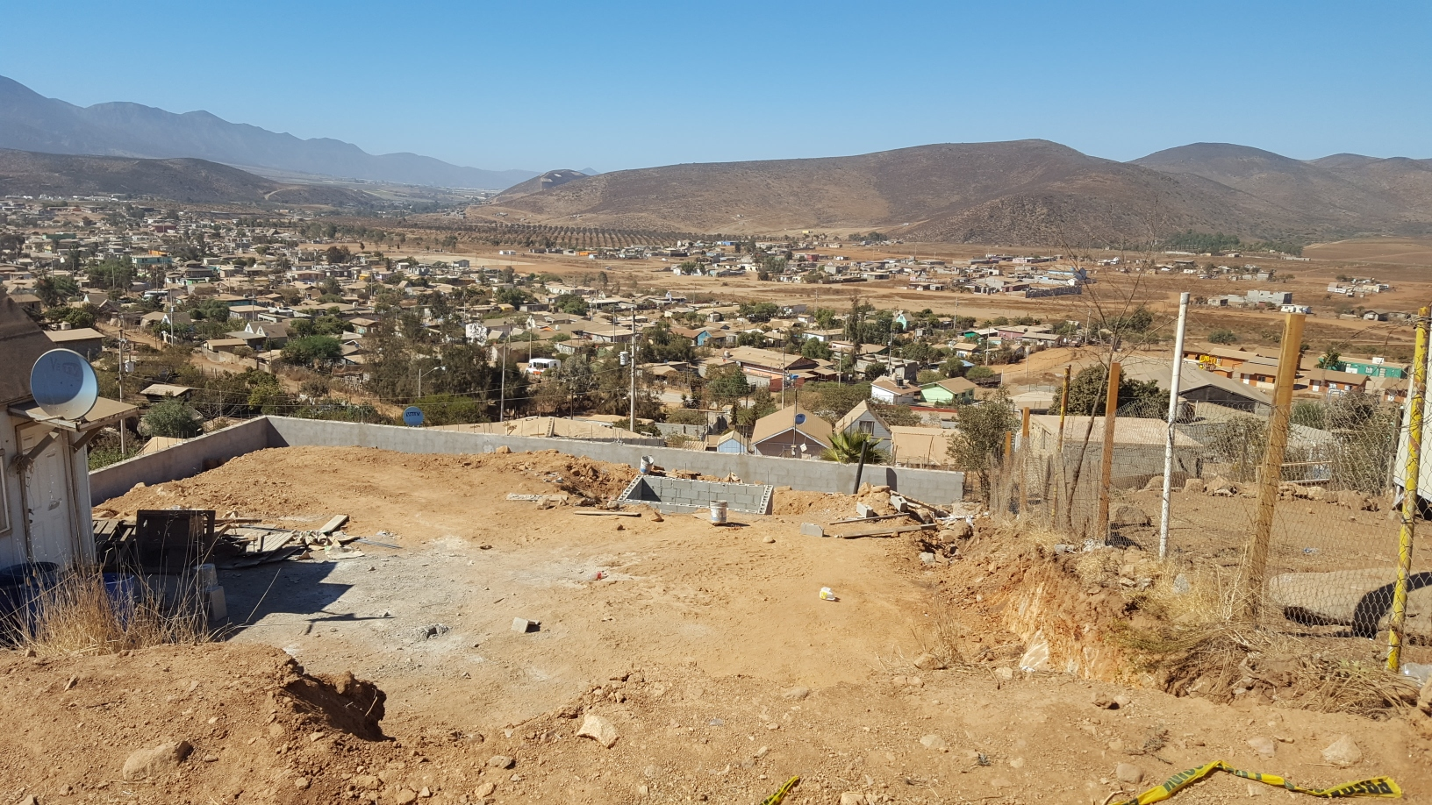
May 11: $270
June 8: $360
July 13: $450

Questions???

If you think of something after the meeting please feel free to give me a call or shoot me a text at 360.483.9210 or send me an email to dmartinez@fcclynden.org

God bless you all!!!!

