Objective: Bellow you will find a list of all the objectives. Your mission is to find as many as you can within the 2 hours that we have here. Each item is represented by points and will be listed to the right of each one. The team with the most points wins! You (or someone on your team) will need a phone that can take pictures and record videos.
Rules: DON’T CHEAT!!! Max 2 people to a team! Be honest, if you lie or cheat you will be disqualified! No acceptations. No rule bending, no if ands or buts! If you cheat you will be disqualified.
Prizes:
First place: Two movie tickets, Two $10 gift cards to Woods Coffee, Two $10 gift cards to Dairy Queen
Second place: Two $10 gift cards to Woods Coffee
Third place: Two $5 gift cards to Woods Coffee
Everyone else: Everyone else gets a high 5 for playing
***IF YOU WIN A PRIZE IN A GROUP OF 2 YOU MUST SPLIT THE PRIZE EVENLY. IF YOU’RE ALONE THE PRIZE IS ALL YOURS**
If you have any questions or get in trouble (please don’t) but if you do or anything at all please give me a call at 360.223.0206
Ready….set….GO!!!

People to find:
Danny 5 points
Gabby 5 points
Jeff Hamstra 10 Points

Get a picture of…:
- Take a picture with a Carnie 1 point
- Take a picture of you on a cow 5 points
- Take a picture of you on a horse 5 points
- Take a picture with someone from our youth group 1 point each
- Take a picture of you in a Jacuzzi 4 points
- Take a picture at A ROASTED DEVELOPMENT 2 points
- You eating corn 2 points
- Get a group picture with 20 other random people 3 points
- Get a picture at little Cesar’s 3 points
- Get a picture at woods coffee 3 points
- Get a picture in front of Connections Christian Store 5 points
- Get a picture at a car wash 10 Points
- Take a picture of you with the Gideon's handing out bibles 2 point
- Take a picture of a guy with a pink shirt 1 points
- Take a picture of you with horses 1 point
- Take a picture of someone wearing a shirt with a cross or bible verse on it 2 points
- Get a picture of you siting on a tractor 1 point
- Take a picture with a police officer and tell them you appreciate them 1 point
- Have someone take a picture of you and your teammate with someone else making a 3 person pyramid 3 points
- Take a picture of an elderly couple holding hands 5 point
- Take a group picture of your team at the clock tower 1 point
- Hug a random stranger (of the same sex) 1 point
- Someone on your team handcuffed by a police officer 5-10 points
- Take a picture with someone really tall 0-3 points
- Holding a cat 2 points
- Selfie with you and your team in a shopping cart 10 points

Video of…:
- Do a dramatic earthquake scene in a public place 1-3 points
- One person on your team dancing in a crowded place for 10 seconds 5 Points
- You being completely immersed in water 10 points
- You high fiving 5 people you don’t know 5 Points
- Playing leapfrog with strangers 5 points
- You licking the cement floor 7 Points
- You eating someone else’s gum 7 Points
- Walking someone’s dog 3 points
- Pushing someone’s baby stroller 4 Points
- Make a video of you telling someone Jesus loves you 2 points
- Make a video of you going up to a stranger and pretending like you have known them all your life 1-5 points
- Take a video of you randomly singing “Row, Row, Row your boat” and dancing near a group of people 2 points
- Take a video of you screaming as loud as you can for 5 second 5 point
- Take a video of you sitting next to someone random and yelling BINGO, BINGO BINGNO!!! And running away 2 points

- Stand on a table (please don’t get in trouble) and for 15 seconds sing the national anthem 3 points
- Start a wave in one of the lines 2 points
- A stranger telling you a joke 2 points
- You and three other people singing a Christmas song 3 points
- Ask a stranger to join you in barking like dogs and meowing like cats 4 points
- A video of you racing in a shopping cart 10 points

Randomzzzz:
- Give one of the Gideon Bibles away 2 points
- Tell a gatekeeper you sincerely appreciate them for helping 1 point
- Bring back something interesting 0-10 points
- Find a flower and give it to someone who needs it (take a picture as well) 1 point
- Get a video of you starting a slow, spontaneous clapping sequence 2 points
- Find someone and pray with them 3 points
- Get a video of you helping someone sell food 5 Points
- Take a picture of Lynden from the top of the Farris Wheel 5 points
- Bring back a bag full of trash you collected 7 Points
- Bring back a compass 7 Points
- Bring back a poster 5 Points

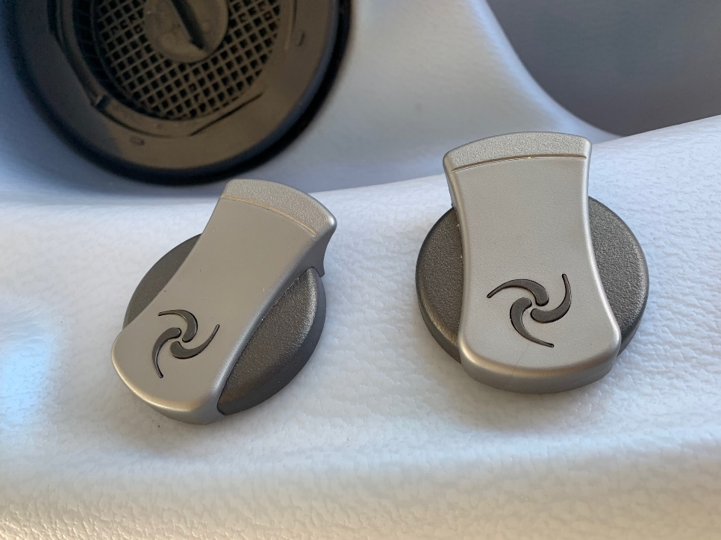
Take a picture of the following items:
10 points extra



15 points extra

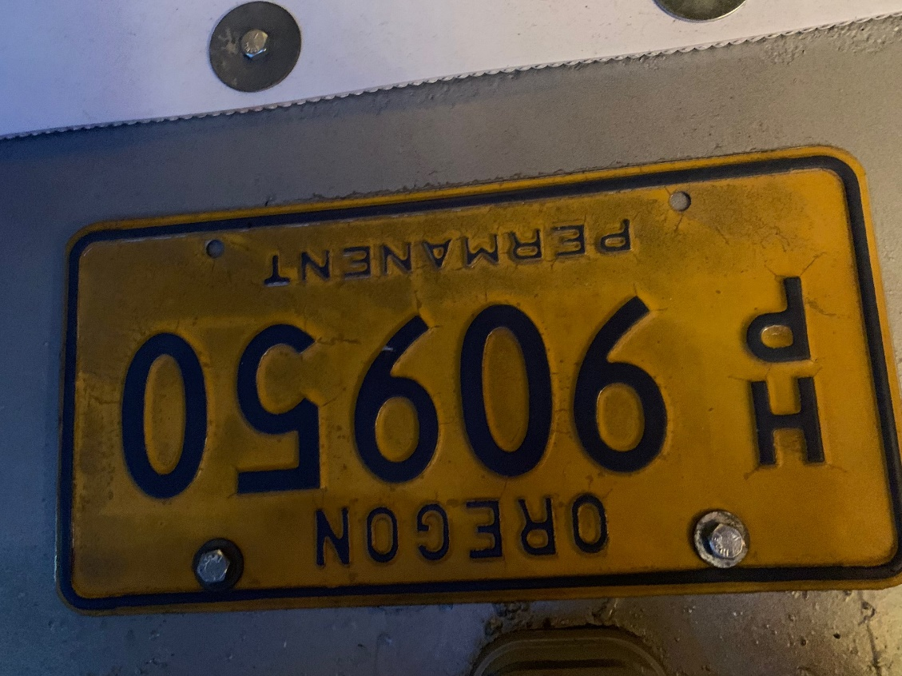
30 points extra

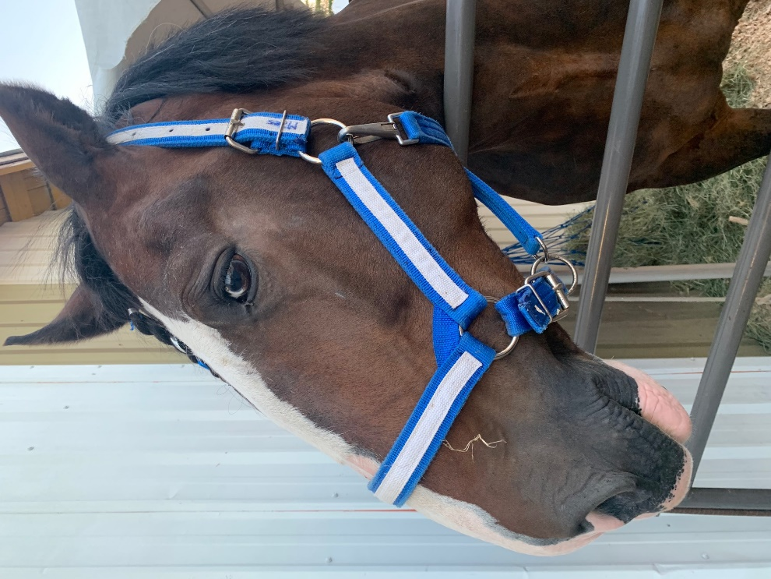

10 points extra

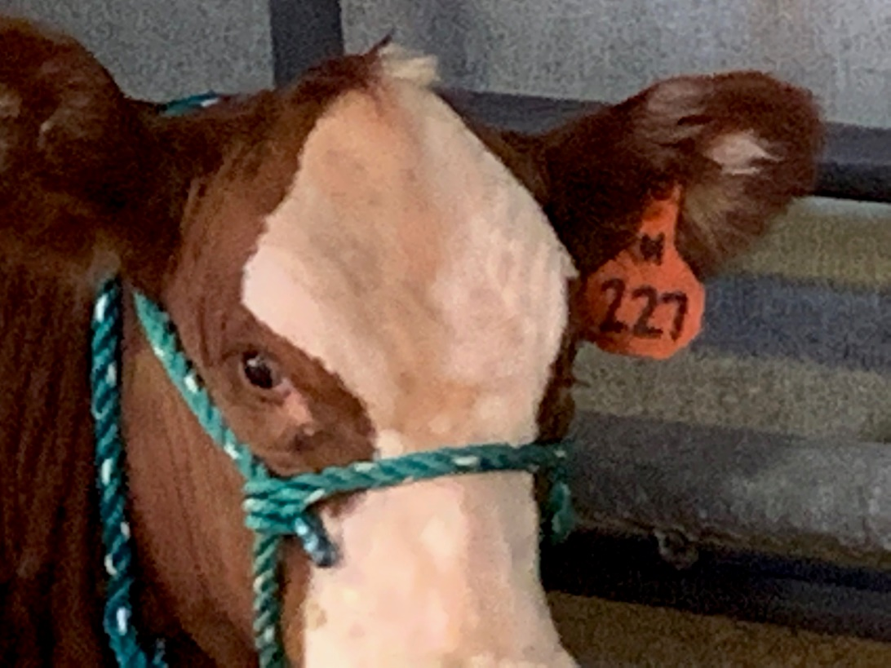

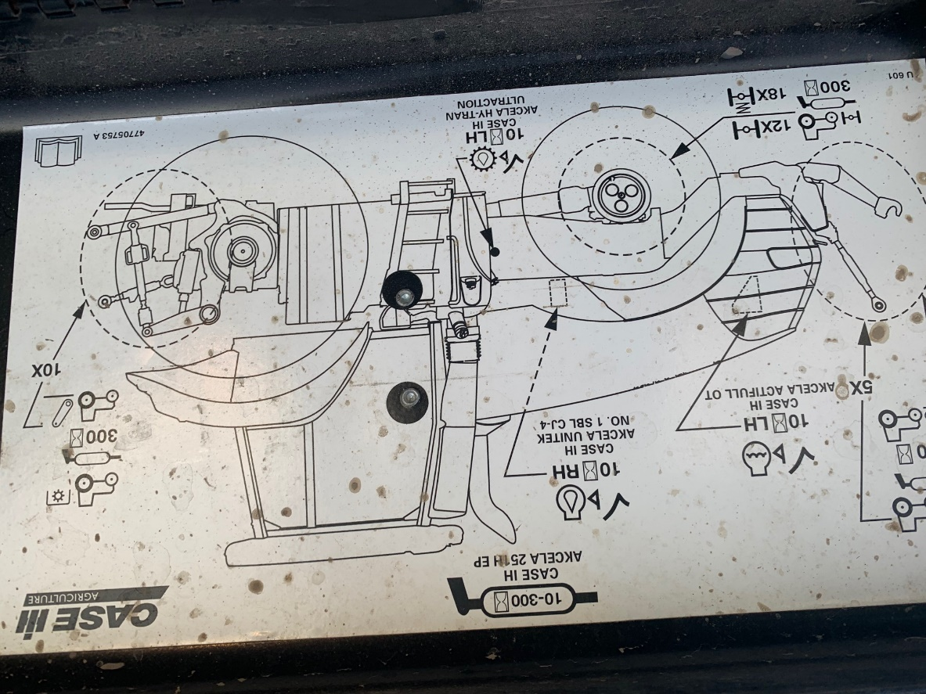
30 Points

20 Points

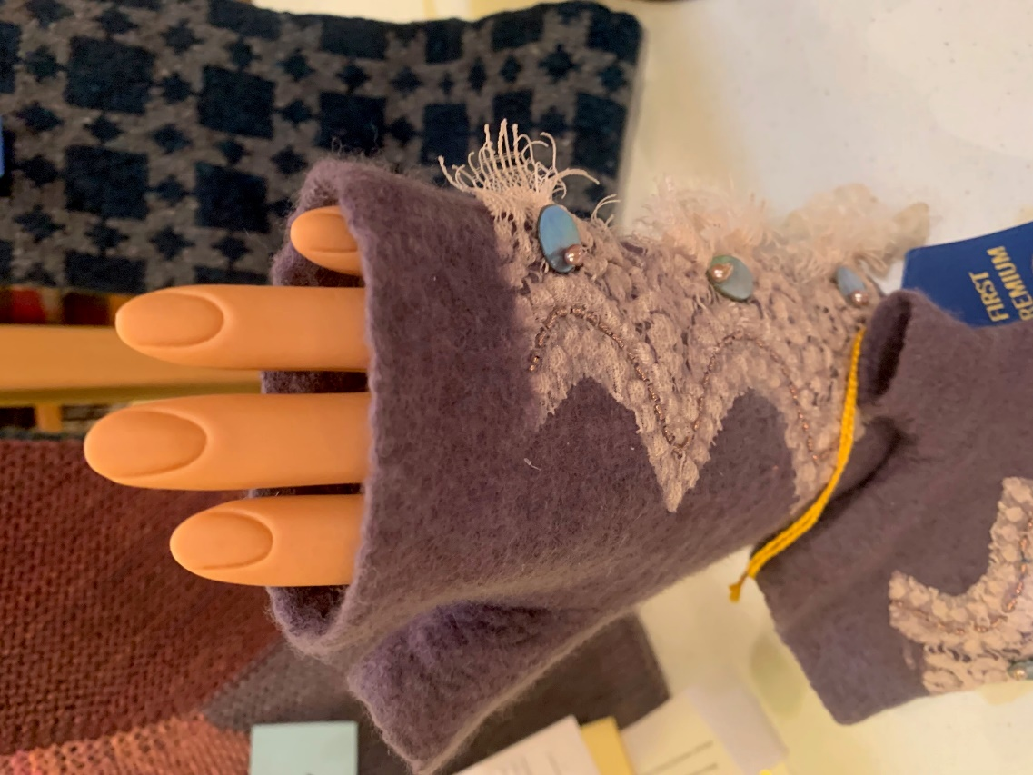
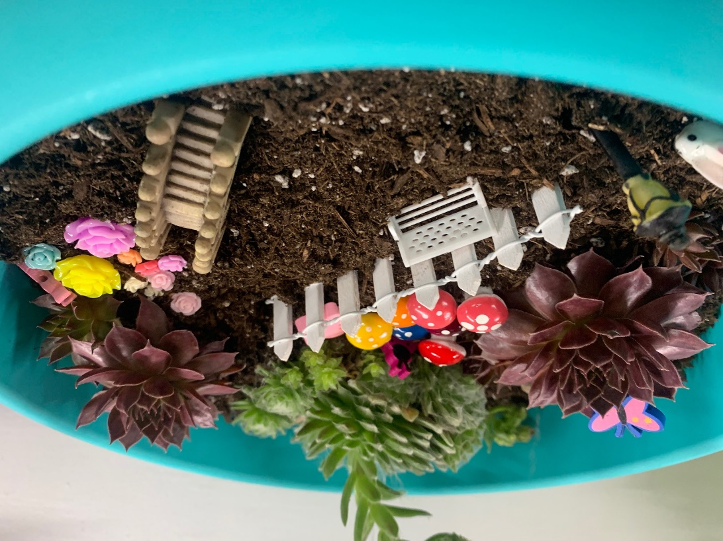

15 Points

10 Points

