The Effects of Pastoral Video Training on Youth Ministry
Daniel Martinez
Trinity Western University

The Effects of Pastoral Video Training on Youth Ministry
Abstract
Over the years it’s come to my attention that there are hardly any video trainings for pastors on youth ministry; the few materials that’s available are either locked behind a paywall or require a lot of time to sit down and go through the videos. What I did was create nine YouTube shorts that will equip and train youth pastors and leaders on practical every day topics related to youth ministry. After almost two years of training and preparation, I uploaded the videos and found out that there was a great response from people who seemed interested in having these 60 second tips and trainings. Because of the data that was collected, it’s safe to conclude that these video trainings did have a positive effect and increased the effectiveness of pastors and leaders in youth ministry.
Literature-Review Section
“Adolescent mental health: the role of youth and college pastors” was published in Mental Health, Religion, and Culture (2014) and looks at what the role is for youth and college pastors in the lives of adolescence and their mental health. The research concluded that most of the youth and college pastors do not feel qualified to work with significant pathology, even though many had some background in psychology. When faced with mental health issues from adolescents, most had an initial counseling session and then they referred the student to a Christian counselor, psychologist, or psychiatrist. Hunter and Stanford both noted that based on research findings in 2002, about half of American adolescents regularly participate in religious organizations either by attending church service or a youth group (Smith, 2002, p. 573). This article also discussed how adolescents who are diagnosed with mental health issues are more likely to seek services from clergy before any other professional group (Hunter, 2014, p. 958). The study shows that there is a need for training to help pastors feel comfortable with seeing and addressing these issues and talking to mental health professionals who can walk along side and co-support the adolescent.
In summary, research suggests that individuals seek services for mental health issues from clergy, and most clergy generally respond with some kind of counselling; however, a majority of them feel unprepared to identify and respond with some kind of counseling. The need and desire for more education is consistently highlighted. (Hunter, 2014, p. 959)
The hypothesis was that training pastors more effectively in recognizing and responding to mental illness would allow them to serve as much more effective “gatekeepers” before they refer. This is because a field study conducted by Farrell and Gobert (2008) found that 71% of pastors surveyed felt inadequately trained to recognize mental illness even though 73% reported at least some training in the area. As ministers, we play a key role in the initial contact when dealing with students because we see them in a context that others (like senior, associate, etc.) might not see them. We have more one-on-one time with them in Bible studies, small groups, mission trips, social events, and in youth group.
While many clergy seem to have some background in psychology even using theories of counseling methods and child/adolescent development training from the past, the need was very clear that more training needs to happen. Some hesitations that youth/college pastors showed when looking at working with mental health professionals were that some were concerned that those providers would not collaborate with them a referral was made (William, 2014, p. 964). Others appeared skeptical and distrustful of mental health professionals. While it is noted that most were willing to work with a mental health professionals, most did not have any reputable contacts or connections to mental health professionals.
“How do pastors connect their academic learning with their pastoral practice: Negotiating the tension between theory and practice”. This was published in 2009 by Equinox publishing and looks at pastors taking their academic knowledge and applying it to their everyday ministry. They took twenty-one participants and divided them into three groups. Eight were recent grads, seven were in ministry for six to fifteen years, and the last group of six had been in ministry over sixteen years. They were all interviewed and asked twenty questions to discuss and explain their experience. What Wong found is that the way pastors navigate this relationship between theory and practice is that they shift approaches depending on the situation and ultimately seek to find the balance between these two (Wong, 2009, p. 244). The article points out observations made by Schwab in 1969 where he says:
The “art” of understanding and interpreting situations of practice involves, first of all, distinguishing between the real thing and its theoretical representations. One must then “modify the theory in the course of its application, in the light of its discrepancies. (Schwab, 1969, p. 12)
Wong saw the need to recognize the differences and adjust to accommodate pastoral practice; practice shapes our understanding of theory (Wong, 2009, p. 245). He gives an example on page 246 of a conflict he had with an elder and how the theory about conflict is important, but knowledge comes from putting that theory into practice. Another example that Wong found from his participants on page 247 is about a pastor who chooses to delegate responsibilities in a crisis situation to a co-pastor because it’s his family night. At first glance, this seems like a selfish thing for the pastor to do, but Wong talks about the importance of recognizing a plurality of viewpoints and how making judgements about them is more likely to achieve the results required. This study shows how it is important for a pastor to be able to move back and forth comfortably between the foundations provided by theory we learn in academic settings, and implementation of that theory in a practical context. Wong goes on to differentiate between theory and practice; theory defined as explanation and practice defined as understanding the skill to know how to do something (Wong, 2009, p. 247). On page 249 Wong talks about how praxis (learning, action, and reflection) is not only the goal for ministers, but a foundational theory. Understanding this will help us improve pastoral ministry by applying our knowledge to practice. The conclusion was that the more seasoned pastors use a “practical approach” when looking at theory application in ministry; this means to be able to go from theory to practice as the need or situation arises. This type of thinking allows theory and practice to co-exist.
“Effect of pastoral crisis intervention training on resilience and compassion fatigue in clergy: A pilot study” was published by Spirituality in Clinical Practice (2018). This research is done to see if clergy who received pastoral crisis intervention training before encountering a crisis situation have more resilience, less compassion fatigue, less burnout, and less secondary traumatic stress than those who didn’t have training. Their hypothesis was that pastors who undergo formal training are less likely to have compassion fatigue and burnout than other clergy who don’t receive formal training (Noullet, 2018, p.2). Many pastors haven’t received any formal training for pastoral crisis intervention and because of this, most are not equipped to deal with the side effects that come with caring for people; similar to the mental and emotional hazards that come with being a first responder.
The sample size was 39 clergy who took a 3-day course and measured a year later to see how they were coping. What Noullet discovered is that clergy who received the training evidenced significantly higher resilience, significantly lower burnout, and less secondary traumatic stress (Noullet, 2018, p.5). Noullet does recognize that one of the limitations is the small sample size, but ultimately concludes that there is great benefit to pastors who receive this training. The American Red Cross utilizes a formal training program along with practices to reduce the adverse emotional effects of exposure among its volunteers and found that they had lower levels of compassion fatigue and burnout than those self-deployed to disaster scenes (Noullet, 2018, p.2). Based on this study, the conclusion is that this kind of training should be required in Bible Colleges, Seminaries, and other ministry related academia as part of their curriculum so that they can better serve the Lord, their community, and the people they minister to (Noullet, 2018, p.6).
Hypotheses
Video trainings are the quickest and best way to equip youth pastors and youth leaders with tips and training across the globe. With time being limited for many people, short clips can provide an increase in access to those who are busy and better equip youth workers for the ministry. Unfortunately, there are limited video trainings available that give quick, comprehensive trainings and tips on how to be an effective youth pastor and leader. This hinders the effectiveness of many who are looking for direction on various topics that are related to working with youth. For this project I’ve set out to create video trainings that are readily accessible for others to use and research how effective these resources have proved in equipping pastors, preachers, teachers, and anyone else who participates in this study. A quick disclaimer: this project is still ongoing and while nine videos have been released, more will continue to come out as I research, prepare, and upload more content in the upcoming weeks, months, and Lord willing years.
My hypotheses is that providing video trainings online will increase the effectiveness of pastors and leaders in youth ministry and better equip them for the work they are called to do. These one-minute video trainings will be scripted, recorded, and uploaded to my YouTube channel as one-minute shorts easily viewable on a cellphone or computer. The brevity of the videos is to maximize the probability that it will be watched completely, allowing the recipients to hear and learn in a timely manner. This is key because as we just read about in the literature above, receiving training is critical when ministering to others.
There is also proof that youth and college pastors are at the frontlines for mental health, but don’t feel equipped to serve their students and families. Lastly, we see how important it is not only to learn about these theories but put them into practice in a practical way. The aim of this project is to further help the pastoral community at large not only to be more educated and have easily accessible video trainings, but to be equipped and ready to put their knowledge into practice in the day-to-day ministries they have been tasked with.
Method
The preparation for this project has been almost two years in the making. In order to create videos, I sought out a local missionary (David Moore with Serve and Equip) who makes video trainings and Bible studies in different languages for people all around the world. He was gracious enough to teach me how to film video, record sound, and how to use DaVinci Resolve video editing software (Appendix B). He has a video studio that we used to record, test, and edit videos. Here we worked on different aspects of video prep like lighting, audience retention, and writing and editing scripts in order to create quality video trainings. Once that was done, I spent more time learning how to upload videos to YouTube in the correct formatting and learning how to make thumbnails that will catch people’s attention. The reason I chose YouTube is because this is the easiest and most widely used way to watch videos. It is also easy to send your content to people and is a resource that many pastors around the world have access to.
Design:
YouTube shorts mimic the success of TikTok, aiming to catch the attention of viewers in just a few seconds; these videos are no longer than 60 seconds. It’s also important to note that this is taken from other popular apps that young people are using like Snapchat and Instagram with it’s stories which is the most used social media platform among young people (Maria, 2021, p.5). This proved to be one of the hardest parts of this project because there is so much research and so many topics to discuss, that narrowing that down to under 60 seconds is very difficult. This is where scripting and post-editing come in handy. Generally, I would keep my scripts from 160-200 words to stay in that time frame, so I had to make sure to choose every word carefully to make sure that the message was clearly conveyed to my audience. As stated in the introduction of this paper, while I only have nine videos out, the project is designed in a way for me to continue uploading more videos discussing topics related to psychology, adolescence, ministry, and faith. The design of this project is something that can be shared and even if there is not a lot of immediate traction on a video, it’s something people can come back to and share in the future to those who are interested.
Procedure:
I began by compiling research from my psychology program (textbooks, articles, past readings) and looking at the various resources I’ve accumulated over the last eight years of pastoral ministry. Then I brainstormed as to what are some interesting topics that I’d like to discuss and what is important to know for youth pastors and leaders. The following list are the nine videos uploaded:
- Psychology & Christianity
- Communication Tips for Youth Pastors
- What Should We Focus on in Youth Ministry?
- Creating a Calendar for Youth Group
- 3 MUST Do’s in Youth Ministry
- Youth Group Game Strategies
- 3 Tips for Sermon Prep
- Improving Your Small Group Time
- Building a Worship Team at Youth Group
On average, each one-minute video required two or three hours of work from the start to final upload; see videos on appendix c.
Participants:
Once the videos had been uploaded to my YouTube channel, I distributed them to my staff, posted it on my Facebook page, sent it out to all my students and parents, and shared it with all the youth pastors here in Lynden. I also have 3,700 subscribers who can access this material.
Results
I’ve been very surprised by how well these videos have been doing. The last video uploaded was on November 19th, 2021 and as of December 1st 2021, they have accumulated 1,426 views and 11 hours of total watch time in 12 days (Appendix A). This is very exciting because I wasn’t anticipating any kind of traction with these videos. Because of these numbers, it’s expected that this resource will reach dozens of other pastors, leaders, and teachers in the next months and years; this is not including any future video trainings that will be released. Time will tell how well this project does, but based on these initial findings and feedback from my colleagues, this seems to confirm my hypothesis that short video trainings do increase the effectiveness of youth pastors and leaders in youth ministry, but the data is still coming in and will need more time to be further examined.
One thing that I did notice was how certain topics were able to pick up more traction than others. For example, my video titled “3 Tips for Sermon Prep” reached the most out of any of my videos with 679 views while my least viewed video is titled “Improving Small Group Time” and only had 14 views. This information has been helpful to me because it can help gauge what kind of videos my audience is interested in. This would prompt more videos on sermon prep for sure to be made and allows me to assess why is it that the small group video wasn’t appealing to people. Another interesting thing that I had learned from some of these results is that my “Psychology & Christianity” video had the worse like to dislike ratio of all the videos. Of the people that gave it a rating, 43% gave it a thumbs down meaning either they didn’t like the video, or they disagreed with the content. My inclination is to go with the ladder because there can be a lot of controversy among Christian circles as to the validity of psychology, the usefulness of its study, among many more concerns. All this data was compiled from studio.youtube.com and logging into my account where they had a list of all the analytics of each of my videos. This data has been helpful with continuing to see what kind of content to create in the future.
Discussion
This project for me has been one that I am very passionate about because I really wish that there were more seasoned pastors, leaders, and teachers who would share their knowledge and experience with the younger generations like me in a way that is easily accessible. While I have less than a decade of ministry experience, my prayer and hope is that someone will benefit from this and that I can even inspire those who are interested in putting material out for others to do it. I initially did not think that this would get very much traction because it is hard to get any kind of viewership on YouTube and was not sure how many people were interested in this kind of content. Through this project I’ve been able to connect with other pastors who are doing similar content, but on a different scale. The numbers that were shown in the results I think speak for the usefulness of this kind of short video training resource and the great need and desire from people to have it. I’m really no one special or have very many credentials, so to have even a small audience is very encouraging and it goes to show that taking a risk and putting some ideas out there in video format with the technology skills I have gained is clearly needed. We talked in the literature review about how there is a need and desire for more training, and this is a great avenue for pastors, teachers, and leaders to be better equipped and be more effective in youth ministry. One thing that is also important to remember is that pastors who have more trainings will generally have a higher emotional intelligence than those who did not and this can lead to a significant reduction in burnout, a higher self-efficacy, and higher job satisfaction (West, 2016, p.236).
Some of the limitations I faced were having a limited time for production, limited research with just me, and limited to only 60 seconds for these video lessons. In a perfect world, I would have a research team and make videos on a higher production and writing scale, however it is an opportunity for others to see that they really don’t need a lot of high-tech equipment or fancy setup to make videos and they can just use their cell phone, free video software, and a cheap microphone like I did. The other limitations that this has is that I don’t know the full effect and benefit because I can’t ask each person that watches my videos if they found them helpful or if it increased the effectiveness of their youth ministry; the only work around would be to create a survey linked to each video in the description to see if I get any response. I would say that this would be my greatest critique of this project. Also, that there are only a handful of videos, and so many topics to discuss. The one on sermon prep can have a lot more videos talking about how to make the most of your prep-time and the same is true with the psychology and Christianity. Based on the viewership and audience retention, it’s safe to imply that there are some people who are finding benefit from these short video trainings; because of this I would say that my hypothesis was correct.
This project has also helped contribute to some of the studies we saw in the literature review. One of the biggest needs is training and these short videos offer it. Another article talked about how we are the frontline workers to mental health problems in adolescence and short video trainings can help those pastors who aren’t sure about how to handle mental health and be better equipped to do so.
Future Research
Some things that I would do in the future would be continuing to make more videos and maybe survey some of the people that I have contact with as to what video content they would be interested in hearing about and what would benefit their ministry. Another thing I could do is select some youth pastors to do a pre and post survey with watching the videos and note changes in their practice. The best thing to do with this project is to continue uploading bi-weekly or monthly a video and further expand my topics and go more in depth with them. Overall, I’m very proud of my work and happy that I was able to learn new skills and discovered a passion in create video trainings for those who are working in youth ministry.
References
Farrell, J., & Goebert, D. (2008). Collaboration between psychiatrists and clergy in recognizing and treating serious mental illness. Psychiatric Services, 59(4), 437-440. http://dx.doi.org/10.1176/appi.ps.59.4.437
Hunter, W., & Stanford, M. (2014). Adolescent mental health: the role of youth and college pastors. Mental Health, Religion & Culture, 17(10), 957–966. https://doi-org.twu.idm.oclc.org/10.1080/13674676.2014.966663
María Cruz López-de-Ayala, García-Jiménez, & Pastor-Ruiz. (2021). Differentiated Uses of Social Networking Platforms among Young People in the Autonomous Region of Madrid. Social Sciences, 10(114), 114. https://doi-org.twu.idm.oclc.org/10.3390/socsci10040114
Noullet, C. J., Lating, J. M., Kirkhart, M. W., Dewey, R., & Everly, G. S., Jr. (2018). Effect of pastoral crisis intervention training on resilience and compassion fatigue in clergy: A pilot study. Spirituality in Clinical Practice, 5(1), 1–7. https://doi-org.twu.idm.oclc.org/10.1037/scp0000158
Schwab, J. (1969). The Practical: A Language For Curriculum. School Review 78: 1-23. doi:10.1086/442881
Smith, C., Denton, M.L., Faris, R., & Regnurus, M.D. (2002). Mapping American adolescent religious participation. Journal for the Scientific Study of Religion, 41(3), 572-587. http://dx.doi.org/10.1111/j.1468-5906.2009.01466.x
West, J. L. (2016). An Analysis of Emotional Intelligence Training and Pastoral Job Satisfaction. The Journal of Pastoral Care & Counseling, 70(4), 228–243. https://doi-org.twu.idm.oclc.org/10.1177/1542305016680629
Wong, A. C. K. (2009). How do pastors connect their academic learning with their pastoral practice?: negotiating the tension between theory and practice. Practical Theology, 2(2), 241–252. https://doi-org.twu.idm.oclc.org/10.1558/prth.v2i2.241

Appendix A
YouTube Video Analytics
Video title | Video publish time | Views | Watch time (hours) | Average view duration | Impressions | Impressions click-through rate (%)
3 Tips For Sermon Prep ✍️ | Nov 19, 2021 | 679 | 3.983 | 0:00:21 | 246 | 2.85
Youth Group Game Strategies 🎮😁🏐 | Nov 17, 2021 | 258 | 2.3921 | 0:00:33 | 427 | 3.04
Communication Tips for Youth Pastors 💬 | Nov 12, 2021 | 161 | 0.9859 | 0:00:22 | 515 | 2.52
Psychology & Christianity - Part 1 🧠 | Oct 22, 2021 | 109 | 2.1149 | 0:01:09 | 225 | 5.33
What should we focus on in youth ministry? 🤔 | Nov 14, 2021 | 76 | 0.7584 | 0:00:35 | 307 | 5.21
Building Worship Team @Youth Group 🎶👏 | Nov 19, 2021 | 73 | 0.4936 | 0:00:24 | 186 | 1.61
Creating a Calendar for Youth Group 🗓️ 😅 | Nov 15, 2021 | 29 | 0.2654 | 0:00:32 | 204 | 2.45
3 MUST DO'S in Youth Ministry 🙌 | Nov 16, 2021 | 29 | 0.2881 | 0:00:35 | 247 | 4.45
Improving Your Small Group Time 💯👌 | Nov 19, 2021 | 14 | 0.1473 | 0:00:37 | 157 | 3.18

Appendix B
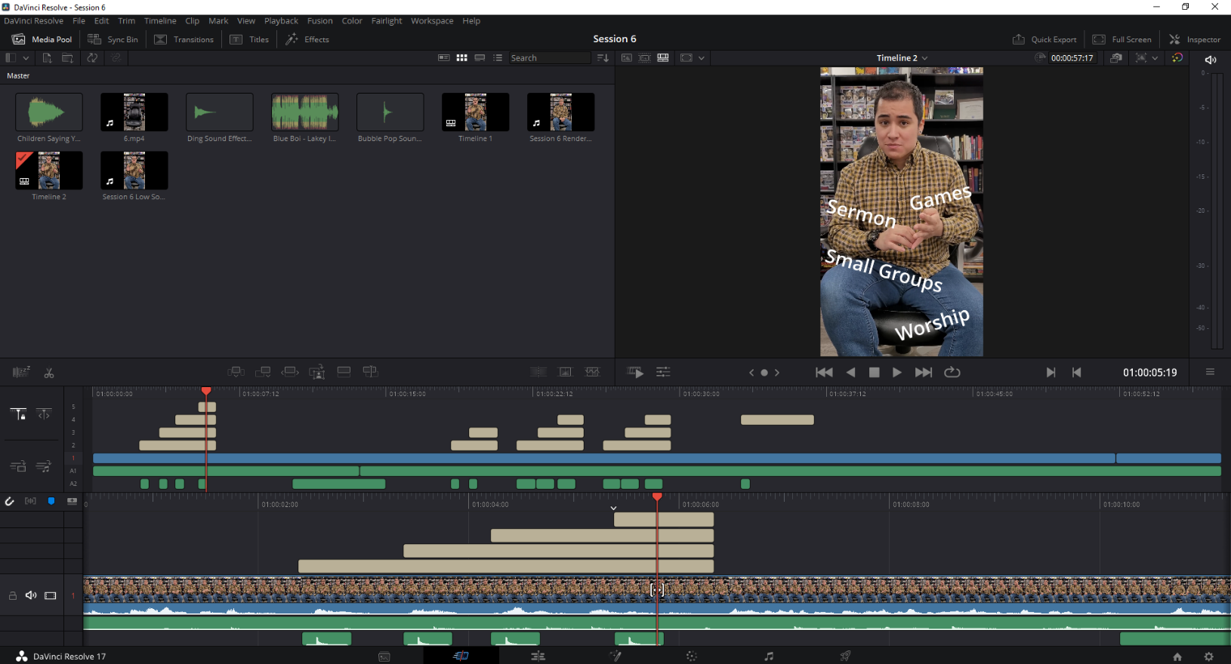
DaVinci Resolve Editing Software
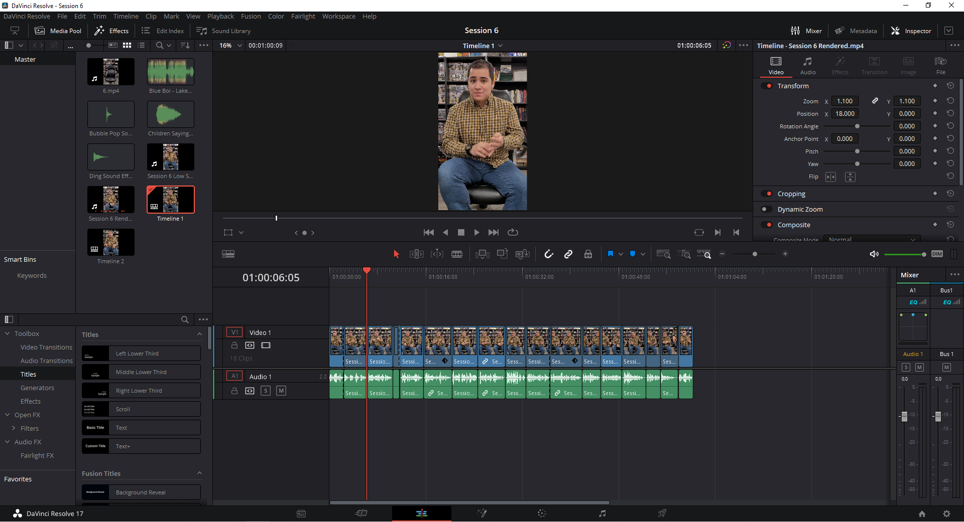
Appendix C
Playlist of my YouTube Videos found on https://www.youtube.com/c/danielmartinezzzz or
https://www.youtube.com/playlist?list=PLeJOlx9Ctt-jmKGpIhqzEv7F0gmti5yyp
