C.B.T. Paper
Daniel Martinez
PSYC 305 – Abnormal Psychology
Trinity Western University

C.B.T. Paper
In our book Abnormal Psychology, we’ve looked at many different types of abnormal behaviors and mental disorders that are found in the human mind; many of which can be treated and some which can’t. Some of these require medication, others a form of therapy which is what has drawn me to C.B.T; not because it’s the end all be all, but rather because I believe that it has great potential to help change the lives of individuals. Now, the old saying “when you have a hammer, every problem looks like a nail” is true in this case. C.B.T. is definitely not for every kind of disorder and disability, however I think it is effective on many people and can be a great tool to have in your repertoire. I recognize that as the years go by, my personal theory of counseling will continue to evolve over my life. Still, I believe that CBT can be very beneficial to the client and yield real time, very practical results as opposed to many other forms of therapy that don’t offer much empirical evidence.
Modern CBT can be credited to psychologists like Albert Ellis who founded the Rational Emotive Behavior Therapy model, Aaron Beck who founded the cognitive therapy model along with his daughter Judith Beck who helped form the Beck institute for Cognitive Behavior Therapy, Christine Padesky and Kathleen Mooney who focus on strengths-based cognitive behavioral therapy, and Donald Meichenbaum who focused on cognitive behavior modification; in this paper I will be focusing more on the work of Beck who looks more at the cognitive side of things and how that affects our behavior. When looking at the theory of personality for CBT and asking the question “What are the key aspects of normal human development?” CBT from Beck’s perspective gives a primary role of thinking as it influences our behavior (Corry, 2016). CBT is not just the idea of positive thinking, but realistic thinking! The theory of how our personality is formed based on our thoughts and perceptions of ourselves and the world around us and that in turn influences our behavior and personality.
From Beck’s approach, he would focus on the thought and how that affects our behavior; as therapists we look at how it’s not so much what happens to us in life, but how we think about what has happened to us. It focuses on our beliefs rather than the events themselves. When looking at the theory of psychopathology and asking the question “How do human beings develop mental health problems?” from a CBT perspective we would answer that by looking at the cognitive processes that happen in the client that reflect this type of behavior. For example, if we’re looking at a patient with low-self-esteem issues who struggles with depression, CBT would aim to look at what perceptions that person would have of themselves as well as look at the spontaneous thoughts they might have and how situations influence their emotional and behavioral reactions. CBT teaches many of the health problems that we can encounter are developed because of irrational and faulty thinking. If we look at a situation, we have automatic thoughts and image that come up which in turn creates a reaction on an emotional, behavioral, and physiological level. (Beck, 2000)
However, there are certain conditions that we would label as “abnormal” that would not fall in this category. Things like somatic symptoms, dissociative disorders, personality disorders, schizophrenia, neurocognitive disorders, and many more would not be things that can be attributed to simply changing the way we see a situation; there are certain times when this can help, but like I said in the introduction, C.B.T. is not the end all be all, but rather a good tool to have in the toolbox (Hooley, 2016).
In Beck’s model of C.B.T., the therapist takes more of the co-learner role, exploring and discovering the client together. This can vary from clinician to clinician; Ellis’s model is different in the way that you are considered the expert in this case. Becks’ model shows us that we should be empathetic towards the client and “sensitive with technical competence (Corry, 2016). There must be a therapeutic alliance for this to work and should be the first step in C.B.T. therapy. Once that relationship is established the therapist will then seek to find testable conclusions to form a hypothesis that the client can work on throughout the week. For example, if the client suffers from a fear of crossing the road, you have an objective problem that you can test out little by little carrying out different “experiments” in the office as well as giving them homework. In the office you could practice rational emotive imagery or role playing it; you get the client to feel what it’s like to cross the road. For homework you could assign cognitive homework which would be having them cross small roads like your driveway first, then a non-busy street nearby and slowly working your way up to where the fear slowly subsites by helping the client be desensitized to the perceived danger of crossing a road.
As C.B.T. therapists, our goal is not so much to lead and dictate to the client what’s going on and what’s wrong, but to be a guide of sorts in the journey of self-discovery. It might be helpful to think of yourself as a shepherd leading and guiding a sheep. Many of the great epiphanies will have to come from the client’s own conclusions, otherwise they renter useless when simply told by the therapist what’s wrong with them. Taking the road example, if the goal of the client is to be able to cross guide meridian at a crosswalk, then we would create small and measurable goals that would lead up to that ultimate goal. Our role should also be to educate them on C.B.T., the nature of their problem, and how the things that they think – crossing roads is scary and might kill me – influence their emotions and behaviors. I would also recommend a book called “Mind over Mood” to them which will help in other practical areas of their lives. Since C.B.T. is often a short 8-10 sessions time, homework is essential for making progress with clients and it’s important that they understand its key role in their healing journey.
Another question that we can now ask is how and why is C.B.T. counseling effective? This is a great question to ask especially when considering if C.B.T. is right for your client. I believe that C.B.T. is a great starting point for many people and for short term therapy sessions. I have found that asking these questions will help decide if this is right for your client:
- Is the client motivated to walk with you in this journey?
- Are they willing to do the homework assigned?
- Is there a clear goal or objective like overcoming anxiety, stress, depression, etc.
- If your client feels generally unhappy or unfulfilled but doesn’t have troubling symptoms or a particular aspect of their life they want to work on, C.B.T. might not be right for them.
Now pertaining to the why CBT is effective this is because unlike many other modes of therapy, you are asking the client to conduct behavioral experiments to test the accuracy of their beliefs. (Corry, 2016) For example, if someone’s belief was “I’ll never be able to talk to women.” You would put them in a situation where he is obligated to talk to a woman say in his class that he’s taking at school. This will attach that faulty thinking and show him that yes, in fact, he can talk to women. In one of my theory books the author, Corry writes “For Beck, people live by rules (underlying assumptions); they get into trouble when they label, interpret, and evaluate by a set of rules that are unrealistic or when they use the rules inappropriately or excessively” (Corry, 2016) The person who sets for themselves a rule/assumption that they can’t talk to women when in fact they can, he just has set unrealistic expectations for himself. C.B.T. is effective because it aims at the core beliefs that we have about ourselves and others and challenges those conscious and unconscious thoughts that we have.
Using the CBT model we look at:
- Situation: What is the activating event?
- Thoughts: What are we thinking in that moment
- Emotional: What feelings do those thoughts stir in us?
- Physical: Do we have any physiological reactions?
- Behavior: What in turn does this thinking cause us to do?
This theory really reflects my personal values, beliefs, and personality because I believe that a lot of the negativity…really the unrealistic thinking that we have affects how we live our daily lives. Paul famously says in Philippians 4:8 "Finally, brothers, whatever is true, whatever is honorable, whatever is just, whatever is pure, whatever is lovely, whatever is commendable, if there is any excellence, if there is anything worthy of praise, think about these things." Paul was in prison during this time and wanted to encourage the church at Philippi to change their mindset. He was using CBT with them right them! Their thoughts and emotions lead to the behavior of desperation, which was totally understandable and justified! But…our thoughts dictate how we react to any given situation. That’s why two people can walk into a church service and say, “Wow that was such a wonderful service” and the other say “Wow that was awful”. Like I had said earlier it’s not just the idea of positive thinking, but realistic thinking! Let’s face it, the world is hard, and we would do a great disservice to our clients have them think that everything is always rosy but helping them realize that they have the power to have a more realistic mindset does wonders! For example, with depression saying “Yes my family is a mess right now, but you know what thank God that they are still with me.” Or even saying “God I know that life is hard, but I trust in you knowing that this too shall pass.” Re-framing your thoughts just like David did in the Psalms.
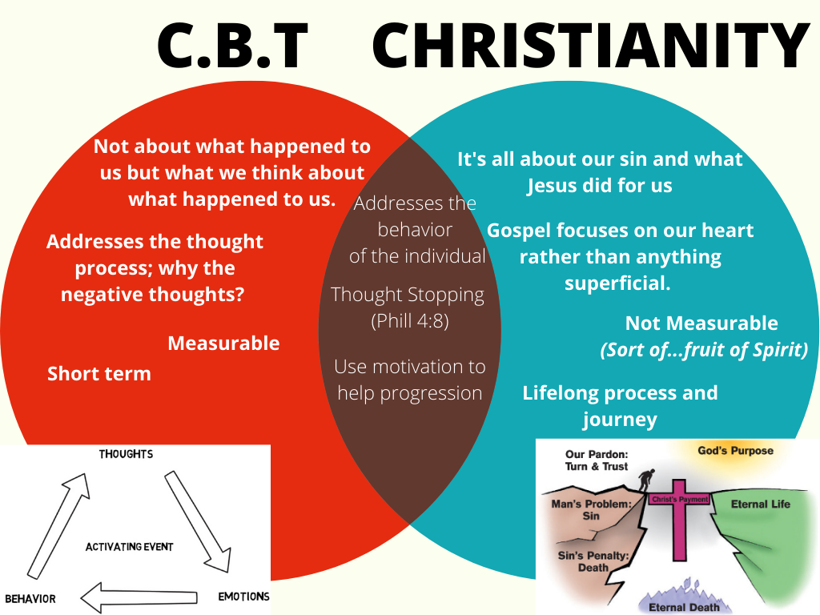
Here is a chart comparing similarities and differences between Christianity and C.B.T. that I made for my power point presentation:

The last question asked is how would this approach be applied to a given population? This approach would be applicable to youth and adults alike. There are many mental health issues that affect both youth and adult that can be treated by using CBT. While it is a short-term therapy, it can also be used in conjunction with other therapies like person centered and family systems. Some practical methods for using CBT to dispute rational beliefs would be: Example would be someone afraid of crossing the road because they might get run over.
- Disputing irrational beliefs: Research how many people get run over a year crossing the road. Looking at the worst-case scenario…in this case not a good one.
  - If it’s looking at a girl rejecting, you then yeah that’s fine.
- Doing cognitive Homework: Start crossing small roads, start crossing driveways.
- Changing one's language: Change saying, “This is a busy road, I’m going to make sure to be careful when I cross so nothing happens to me” Cannot do is now CAN DO!
- Using humor: Laugh about it, see the funny side of it.
- Rational emotive imagery: Get client to feel like what it is to cross the road. Goes along with roleplay.
- Role play: Try it out!
- Shame-attacking exercises: Don’t be ashamed of your fear! Lots of people have these fears. Don’t beat yourself up about it.
- Use of motivation: If you cross these roads, what is the benefits?
- Desensitization: Get someone to go with you! Like exposure therapy. Do it and repeat until it becomes second nature to you.
- Skills training: Teaching how to cross the road, when to cross, where to cross.
- Assertiveness training: Difference between assertiveness and aggressive. Asking what you want rather than bullying.

Looking more at helping through the spiritual side, I think that this form of counseling does lend itself to being open to the spiritual or sacred things in the lives of an individual. The Bible teaches how Jesus came to make broken things whole and that’s exactly the goal of C.B.T.; it might not be to make every part of the person whole again, but maybe if it’s just working on setting personal goals to overcome anger, or anxiety, or some other issue. C.B.T. allows each person to track the progress in a practical way. Revelation 21:5 says, "And he who was seated on the throne said, “Behold, I am making all things new.” He also said, “Write this down, for these words are trustworthy and true.” For many people, old ways of thinking can be made new by using C.B.T. As Christians we understand that while it may not be perfect this side of heaven, it’s possible to overcome obstacles and hurdles in our lives by using psychotherapy methods like C.B.T.
While CBT is far from perfect, we must ask ourselves one final question: is CBT a Band-Aid approach to therapy or is it surgery? Is it effective long term or is it just a short term therapy? The answer to that is yes. Yes, it can be a surgery and yes it can be a Band-Aid approach leaving many things from family origin and past undiscovered. If you factor in abnormal psychological factors, there are some things that C.B.T. is just not equipped to treat. It all comes down to your specific situation with the client and that’s why I would advocate using C.B.T. in conjunction with another method of therapy. However, there are countless stories online about how C.B.T. has changed their lives, gotten them out of depression, helped them with anxiety, really given them a new lease on life! I hope in the future if God allows me to be able to use C.B.T. in a professional setting and as I grow and learn more about it and other forms of therapy to be able to effectively impact the lives of those hurting and needing of someone to walk beside them and be the holder of their stories.
References
Corey, G. (2017). Theory and practice of counseling and psychotherapy. Boston: Cengage Learning.
Beck, A. (2000). Cognitive Model: Theory of Psychopathology: Beck Institute. Retrieved from https://beckinstitute.org/cognitive-model/
Beck, J. (2012, March 27). A Conversation with Aaron T. Beck. Retrieved from https://www.youtube.com/watch?v=POYXzA-gS4U
Greenberger, D., & Padesky, C. A. (2016). Mind over mood: change how you feel by changing the way you think. Second edition. New York, NY: The Guilford Press.
Griffith, J. L., & Griffith, M. E. (2003). Encountering the sacred in psychotherapy: How to talk with people about their spiritual lives. New York: Guilford Press.
Hooley, J. M., Butcher, J. N., Nock, M. K., & Mineka, S. (2016). Abnormal Psychology - (17th Edition) (17th ed.). Pearson.
Morton, K. (2013, September 23). Retrieved from https://www.youtube.com/watch?v=g7B3n9jobus.

