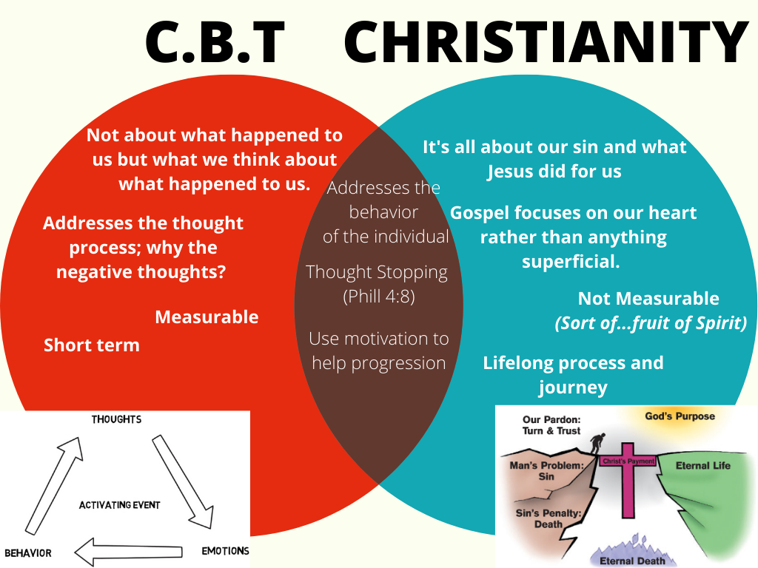
C.B.T and Christianity
Daniel Martinez
Trinity Western University
C.B.T. AND CHRISTIANITY
C.B.T. is one of the best ways for therapists to help their clines address issues in their lives and overcome hurdles that they haven’t yet been able to on their own. It’s also a wonderful self-help tool that everyday people can use with the correct guidance. I chose C.B.T. because it’s the one that I find myself most drawn to; while I recognize that as the years grow by and my personal theory of counseling will continue to evolve over my life, I firmly believe that C.B.T. can be very beneficial to the client and yield real time and very practical results as opposed to many other forms of therapy where you don’t always have empirical evidence readily available to you.
C.B.T. is not just the idea of positive thinking, but realistic thinking! The theory of how our personality is formed based on our thoughts and perceptions of ourselves and the world around us and how that in turn influences our behavior and personality. In my diagram on the title page I stated how C.B.T. isn’t about looking at our past, but rather addressing how we think and act on what happened to us. It also helps us look at our thought process and ask the question “Why did that thought just come into my head”? Or “Why do I feel this way”? What this form of therapy does is it helps us look at the activating event, and how from that event we have thoughts, which lead to influencing our emotions, which then affect our behavior. Now when they are good thoughts and emotions that’s great! But when they aren’t that is a difficult hurdle to overcome; C.B.T. helps people change the way that they think which helps them change the way they live.
Christianity at first glance doesn’t have much in common with C.B.T. One is measurable another isn’t – I mean you can’t empirically measure your Christian faith, but scripture does provide us with evidence of a true believer – one focuses on our thoughts and behaviors while Christianity focuses on our heart and our sinful nature, and C.B.T. is generally a short term therapy while Christianity is a lifelong journey of sanctification that doesn’t stop until the day we die. However, they do share some things in common the first of which is addressing the behavior of the individual. Christianity isn’t explicitly about addressing our behaviors and any genuine Christian will tell you it’s more than just behavior modification (superficial faith which will lead you nowhere, see Matthew 23:27-28) but I would be wrong in saying that Christianity doesn’t change the way we live. The Bible talks about being transformed (Romans 12:2-3), about not being the same person anymore (Galatians 2:20), and having new attitudes towards others and towards yourself (Galatians 5:22-23). C.B.T. is all about that!!! They share this common goal of getting rid of undesirable traits and behaviors and replacing them with good and positive ones!
Obviously depending on your worldview this is subjective, however this is something that Christianity and C.B.T. do share in common. They also share a great tool found in C.B.T. which is thought stopping. Basically that’s catching your thoughts as they come and stopping the bad ones from continuing to influence your emotions sometimes by even audibly saying STOP! Philippians 4:8 says "Finally, brethren, whatever things are true, whatever things are noble, whatever things are just, whatever things are pure, whatever things are lovely, whatever things are of good report, if there is any virtue and if there is anything praiseworthy—meditate on these things." So this is a biblical concept of thinking/meditating on good things rather than bad ones.
Lastly the similarity they share is using motivation no progress. No matter if it’s a short term goal with C.B.T. or a long term one like hearing Well done, thou good and faithful servant (Matthew 25:23) Christians and those who use C.B.T. are motivated by the end goal. At the end of the day changing the way we think and changing our behaviors is a big part of what Christianity is about; while there is so much more, these are key pillars that they both share.

