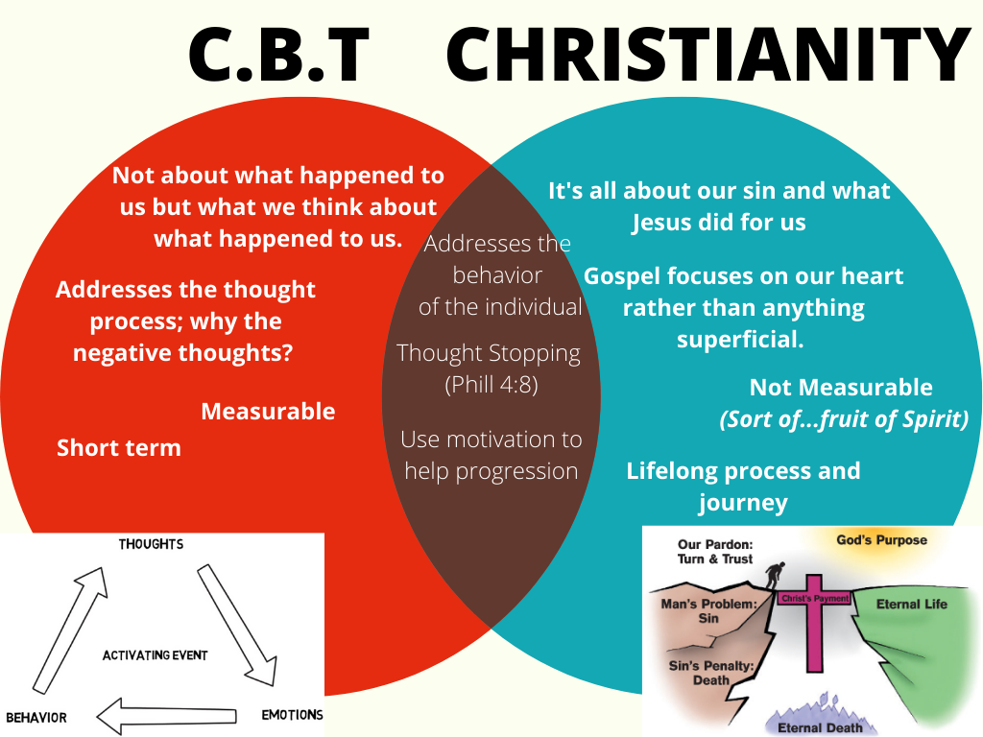
Beck would focus on the thoughts and how that affects our behavior. It’s not so much what happens to us, but how we think about what has happened to us. It focuses on our beleifs.
Not just the idea of positive thinking, but realistic thinking! CBT works at tracing automatic thoughts and beliefs we hold either consciously or unconsciously.
Founded primarily by Aaron Beck around since 1960s. Cognitive psychology and behavioral psychology now joined. 1970s studied depression. As good as meds. 80s anxiety. Then took on personality disorders. A combination of Cognitive and behavioral psychology.
- Cognitive: id, ego, super ego Freud. Alder furthered that work consciousness, pre-consciousness, and unconsciousness.
- Behavior:
  - Classical conditioning: Pavlov making the dog drool by the sound
  - Operant conditioning: Watson Positive reinforcement, negative reinforcement behavior go up. Punishment will make the behavior go down

What is C.B.T.?
Define the Terms
Cognitive: Examining the things that you think
Behavior: Examining the things that you do.
- Focuses on issues in the present day; things that are affecting your life now.
- It’s measurable, so you can get empirical evidence for your client’s progress.
Helps you understand what’s going on in your heard and gives you tools on how to control that.

Activating event, thoughts, emotions, behaviors

Group exercise:
Think of situations where you can give the group examples…
- Close your eyes and imagine…your alarm goes off, you hit snooze for 5 more minutes. Then you wake up, look at the clock, and its 7:45 and you’re supposed to be at work at 8:00. What are you feeling?

- You’re invited out to go to a social event…say a wedding. The only person you know is a friend of the groom and everyone else is foreign to you. What is the internal dialogue that you’re having?

- You call a friend or loved one and they don’t answer…What are you thinking?

What CBT aims to do is change the way you think by challenging/disputing irrational thoughts and beliefs that you hold. These can also be called automatic thoughts.
Triggers/Beliefs (top)
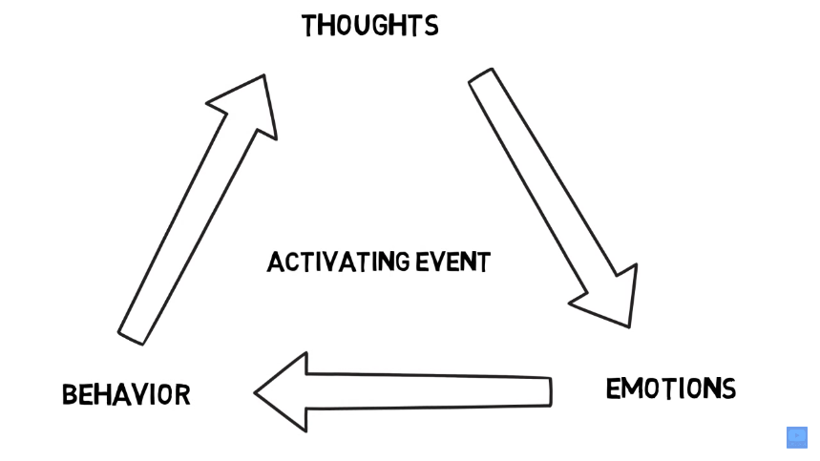

How do we do this? (use the board to draw: talk about yourself)
Cognitive Behavior Therapy: Short term and measurable. Believes our life and experiences aren’t what happens in our lives, but how we think about what happened in our lives.
Slide
  - Tool: Thought tracking. My dad left…how did that make you feel?
  - Underlying assumptions: Downward arrow thinking
    - Recognizing those thought that come down
  - Thought stopping: Stopping those negative thought that come in your way today. Verbal or in your head. Philippians 4:8
Another tool MINDFULNESS
Play: https://www.youtube.com/watch?v=OaRDbLWeSXE & https://www.youtube.com/watch?v=w6T02g5hnT4

A: Activating event; Takes the thing personal=resulting emotion
B: Behavior; why two people can have two different views about the same event

We see the world through the lens of our emotion. This is Emotional reasoning. Why companies advertise to our emotions.
Is CBT right for my client?
It’s a good starting point for some and for short-term therapy sessions…maybe 8-10.
- Is the client motivated to walk with you in this journey?
- Are they willing to do the homework assigned?
- Is there a clear goal or objective like anxiety, depression, or schizophrenia?
- If your client feels generally unhappy or unfulfilled, but doesn’t have troubling symptoms or a particular aspect of their life they want to work on, CBT might not be right for them.

Another technique that really goes hand in hand with CBT is mindfulness
That’s basic mindfulness. I would encourage you to read that mindfulness handout we got. Talks about fixed mindsets which are people who interpret mistakes as threats to their ego rather than as opportunity s to improve and growth mindsets that self-assess and are more open to accurate information about where they are even if it’s unflattering. That stems from the belief that they can develop and improve.
- Situation…what is the activating event?
- Thoughts
- Emotional feelings
- Physical
- Behavior
Scenario 1: Monday morning, a rainy day, hard to get out of bed, she says “I’m going to be a bad day because today is a bad day.” (Thought) I feel depressed (feeling) “I’ll call in sick today” (behavior)
What CBT aims to do is break that cycle of thinking and help you get rid of those irrational ideas.
Scenario 2: Same day “I’m going to push myself to get out of bed today and
(Draw on the board: Thought, feeling, behavior in collums)
- Passing by a friend who ignored you…could have ignored you because
- You smile at someone and they don’t smile back…. What from above do they make you feel?

Methods used in CBT is disputing irrational beliefs:
Example would be someone afraid of crossing the road because they might get run over.
- Disputing irrational beliefs: Research how many people get run over a year crossing the road. Looking at the worst case scenario…in this case not a good one.
  - If it’s looking at a girl rejecting you then yeah that’s fine.
- Doing cognitive Homework: Start crossing small roads, start crossing driveways
- Changing one's language: Change saying, “This is a busy road, I’m going to make sure to be careful when I cross so nothing happens to me” Cannot do is now CAN DO!
- Using humor: Laugh about it, see the funny side of it.
- Rational emotive imagery: Get client to feel like what it is to cross the road. Goes along with roleplay.
- Role play: Try it out!
- Shame-attacking exercises: Don’t be ashamed of your fear! Lots of people have these fears. Don’t beat yourself up about it.
- Use of motivation: If you cross these roads, what is the benefits?
- Desensitization: Get someone to go with you! Like exposure therapy. Do it and repeat until it becomes second nature to you.
- Skills training: Teaching how to cross the road, when to cross, where to cross.
- Assertiveness training: Difference between assertiveness and aggressive. Asking what you want rather than bullying.

Changes negative thoughts to good thoughts. Testing them against reality; what thought are holding us back?
- Won’t dismiss their beliefs, but will help change them to better ones.
- Help find the root of these thoughts. Can’t change what happened, but can change how we act and think about these situations.

Examples of irrational ideas.
- "I must have love or approval from all the significant people in my life."
- "I must perform important tasks competently and perfectly"
- "If I don't get what I want, it's terrible, and I can't stand it."

Therapist job is to help you think a different way.
During sessions clients can often have self-deprecating thoughts that can cause anxiety and discomfort, it’s important with CBT to acknowledge those moments…those cringes and little ticks we might see.
If there is to be success with this method, thoughts and behaviors must change, otherwise there will be no long term success.

