Monster reported 69 percent of burnout during the pandemic. Up 35% from may.
https://www.youtube.com/watch?v=v62TMMzBv4U&ab_channel=CBSThisMorning
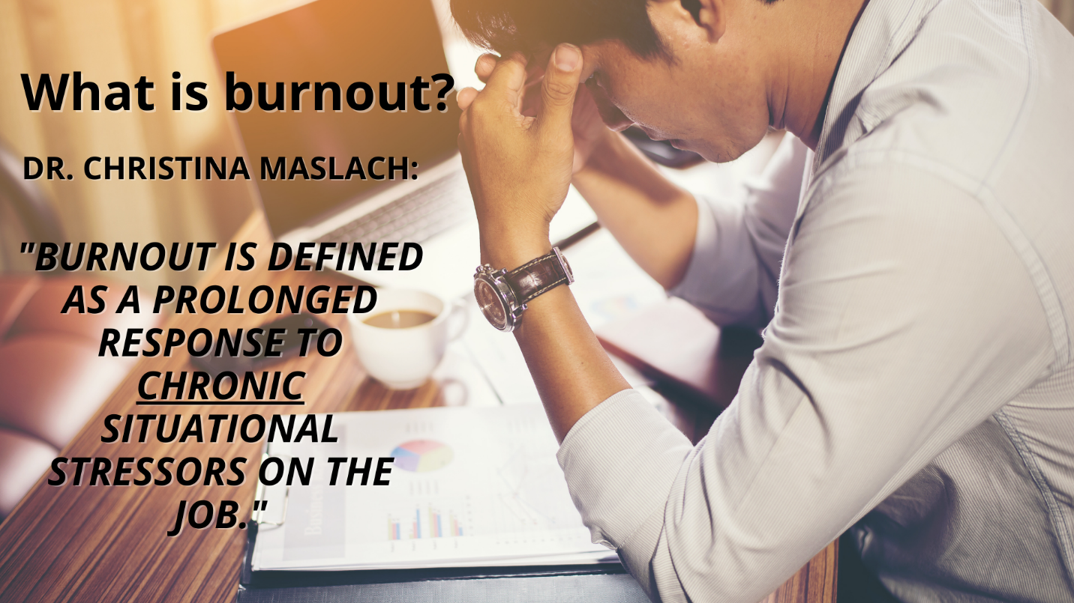
Dr. Christina Maslach:
an American social psychologist and professor emerita of psychology at the University of California, Berkeley, known for her research on occupational burnout.

The pressure to address job burnout became so intense in 2019 that the World Health Organization (WHO) declared burnout an occupational phenomenon1 in its global standard for diagnostic health information, the 11th revision of the International Classification of Diseases.2
Burnout definition: Burnout as a Stress Phenomenon
Burnout is a prolonged response to chronic situational stressors on the job. A good analogy is that of rocket boosters and ball bearings being in an abrasive environment without one key resource: oil.
What is the “oil” in our lives that keeps us from burning out? That’s what we’re going to discuss today.
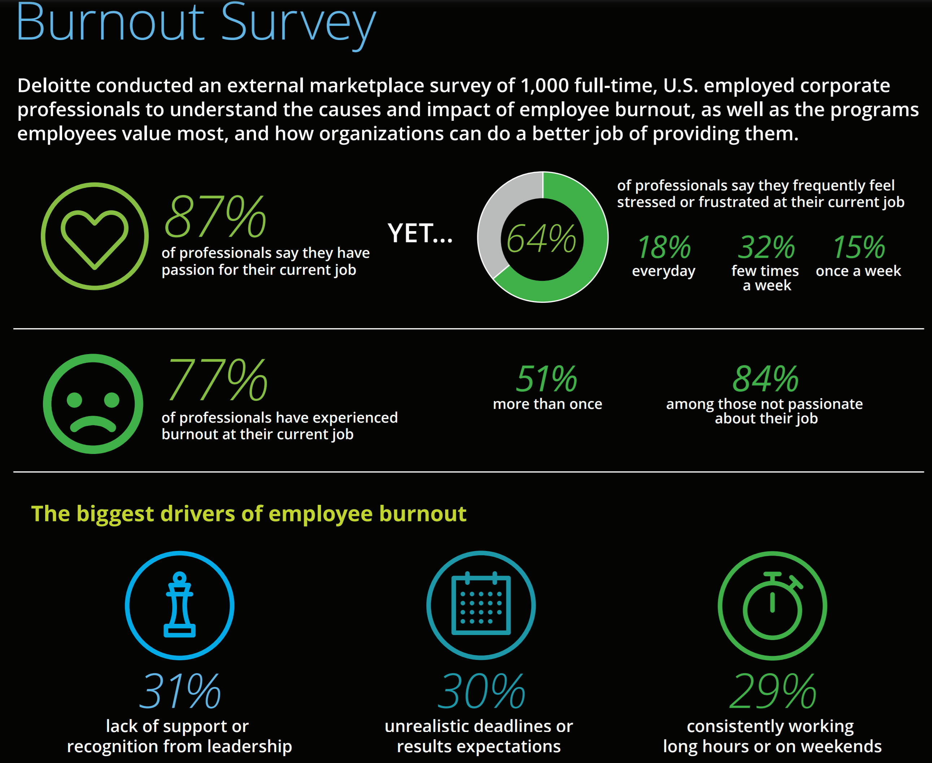

https://www.youtube.com/watch?v=WM3wjwGyXes&ab_channel=JosephLiu
physically tires, mentally fatigued, others notice. Signs of job burnout.
https://josephliu.co/7stagesofcareerchange/
https://www.youtube.com/watch?v=83LPVejgujw&feature=emb_logo&ab_channel=JosephLiu
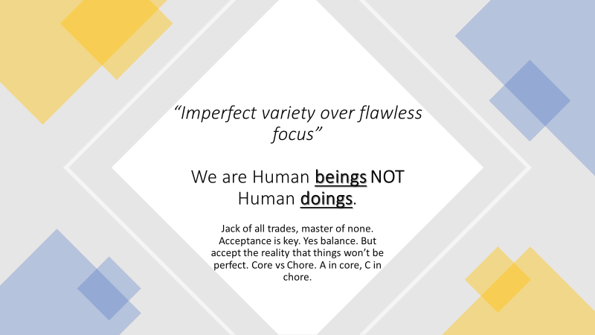
Burn out definition idc-11
https://www.who.int/news/item/28-05-2019-burn-out-an-occupational-phenomenon-international-classification-of-diseases
Burn-out is defined in ICD-11 as follows:
“Burn-out is a syndrome conceptualized as resulting from chronic workplace stress that has not been successfully managed. It is characterized by three dimensions:
- feelings of energy depletion or exhaustion;
- increased mental distance from one’s job, or feelings of negativism or cynicism related to one's job; and
- reduced professional efficacy.
Burn-out refers specifically to phenomena in the occupational context and should not be applied to describe experiences in other areas of life.”
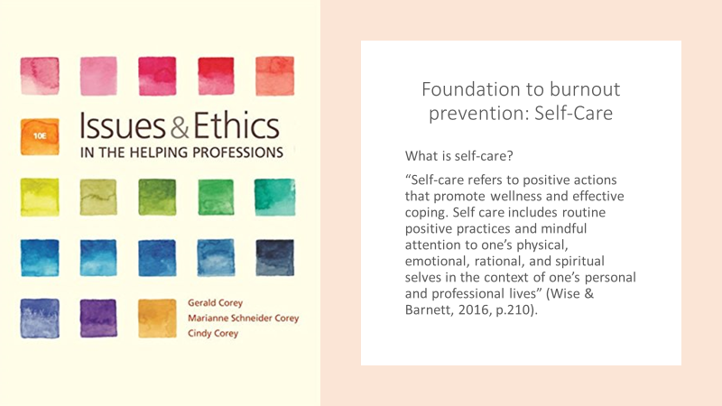
Gallup study
https://www.gallup.com/workplace/323228/remote-workers-facing-high-burnout-turn-around.aspx

https://www.gallup.com/workplace/288539/employee-burnout-biggest-myth.aspx
Management style, creating a personl day for people to realise it’s not work that is stressing them out
Emproyees that experience burnout are 2.6 times more likely to be looking for employment elsewhere.
https://www.gallup.com/cliftonstrengths/en/299855/how-to-improve-my-career.aspx
